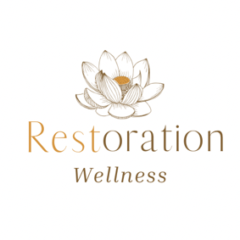

Ear Candling Waiver

I understand that this ear candling session is for the purpose of possible stress reduction, supporting cleansing processes, and energy flow. I understand that the person performing this session cannot be held liable for anything related to this therapy and that she does not diagnose illness, disease, or any other physical or mental disorders. She does not prescribe prescriptions, or medical treatments.

I understand that this is not a substitute for medical examination and/or diagnosis, and that it is recommended that I seek a medical Doctors opinion for all such matters.

I acknowledge that I have never had any ear surgeries, nor am I suffering hearing loss of any kind. I understand that I would not be a candidate for this treatment if so.

By signing this release form, I do hereby waive and release Restoration Wellness, the practitioner, and any affiliate from liability, past, present, and future.

Client Signature______________________________ Date_________________
Emergency Contact___________________________ Phone #______________

Practitioner Signature_________________________ Date_________________

