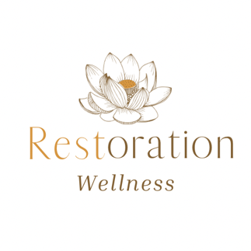

Infrared Therapy Mat Session Waiver and Release of Liability

Read Carefully

This waiver is for an infrared therapy session on an infrared therapy mat. I agree to observe and cooperate with all instructions or directions given by Restoration Wellness for the use of this mat. I understand that there are certain risks involved whenever using heat from an infrared source and I assume full responsibility and/or personal injury if such occurred. I acknowledge that if I have heat sensitivity, narcolepsy, fainting spells, or a history of dizziness then I should not be using this form of therapy. I understand that if I am pregnant or breastfeeding this is not an ideal therapy for me. I understand that I am not a candidate for this therapy if I have a battery operated or electrical implant, or pacemaker. I understand that if I have high blood pressure, have had a heart attack, or have a cardiovascular problem, then I am not a candidate for this therapy.

I understand that it is important to drink water and maintain proper hydration before and after this therapy.

None of this information is to act as medical advice, nor does it involve the diagnosis, prognosis, or prescription of remedies for the treatment or prevention of any disease or ailment. I certify that everything on this form is true and correct to the best of my knowledge. This treatment is not intended to treat, cure, diagnose, or prevent any disease or ailment.

I agree to pay for my appointment in advance and arrive on time. There are no refunds for no show appointments.

I release all liability by signing this waiver.

Signed__________________________________________ Date_________________
Witnessed by____________________________________ Date__________________

